

The Intelligent Surveillance Solution

NUUO MainConsole &
Cardax FT system Integration
User Guide

V1.0.0
NUUO MainConsole (For NVR IP+, Hybrid NDVR, DVR card) and Cardax FT Access Control System has been integrated, coporating to provide an interface between the two platforms, to provide LiveView and Playback fo Cardax FT events.
NUUO – Cardax interface allows Liveview/Playback video from NUUO server to be accessed within the Cardax FT Software.
Live video can be instantaneously displayed when an alarm or event activation occurs. Playback enable users access the recorded video from NUUO server.

LiveView
Step 1:Launch Cardax Command Centre FT -> Configuration -> External System.
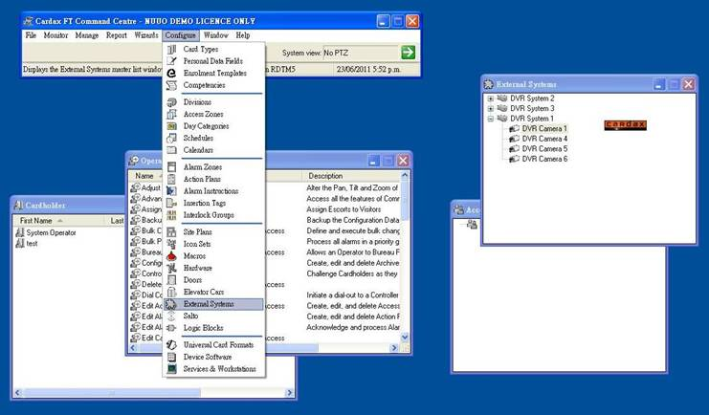

Step 2: Set DVR System 1 to link MainConsole server(from properties setting page):
IP Address format: MainConsole Server IP Address : Liveview server port : Playback server port
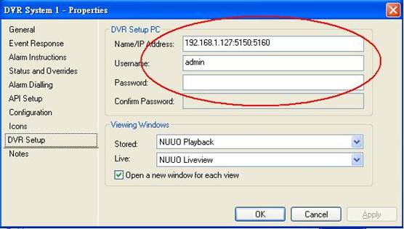

Step 3: Setup a camera.
Identification means channel index of MainConsole server, index start from 0.
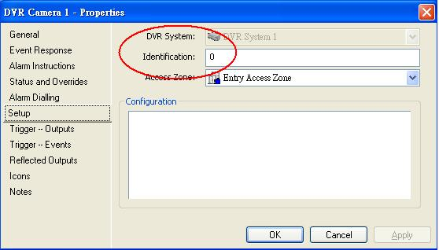

Step 4: Preview.
Select DVR camera 1 -> right click -> Watch, then you can see video.
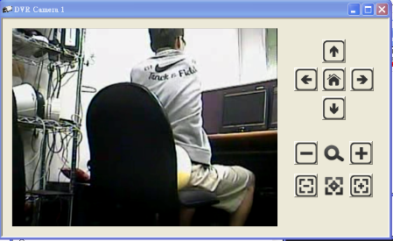
Resolution: 480x300
Icon definition:
 | Up |  | Zoom in
 | Down |  | Zoom out
 | Left |  | Focus near
 | Right |  | Focus far
 | Home

Playback

Step 1:Launch Cardax Command Centre FT -> Configuration -> Hardware.
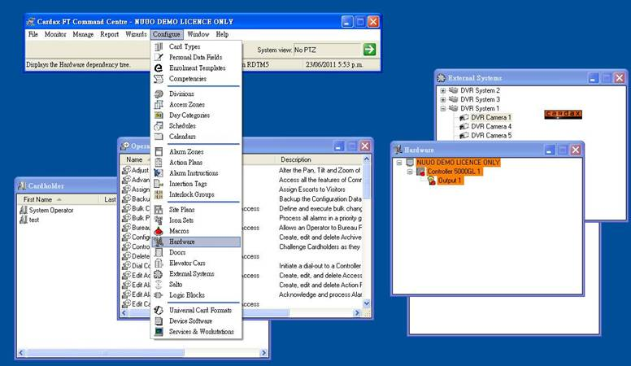

Step 2: Trigger output event:
You can trigger output event from right click -> On / Off.
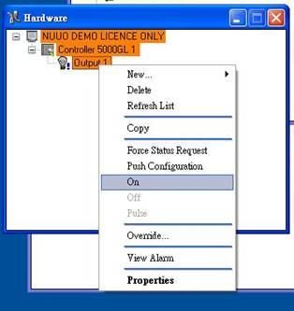
Then you can see the event appears in Monitor -> Alarm Viewer dialog.

Set the corresponding action when DO trigger as view stored video.
We get 10s video after DO is triggered on (before triggered time 5s ~ after triggered time 5s).

Step 3: Watch the video:
Right click event and select View.
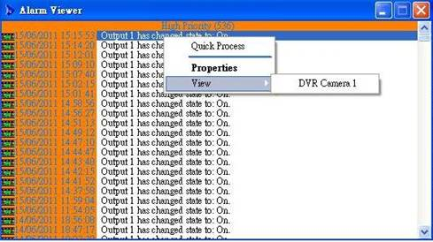

Then you can see the video:
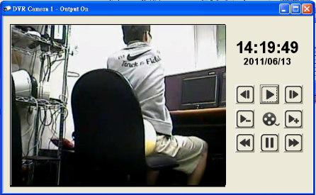
Resolution: 480x300
Icon definition:
 | Step backward |  | Rewind (Previous Interval)
 | Play |  | Pause
 | Step forward |  | Fast forward (Next Interval)
 | Speed down
 | Speed up

